**Week1:**

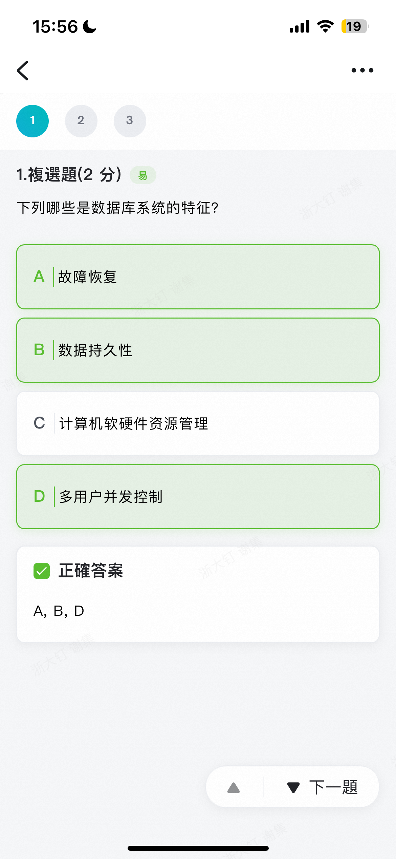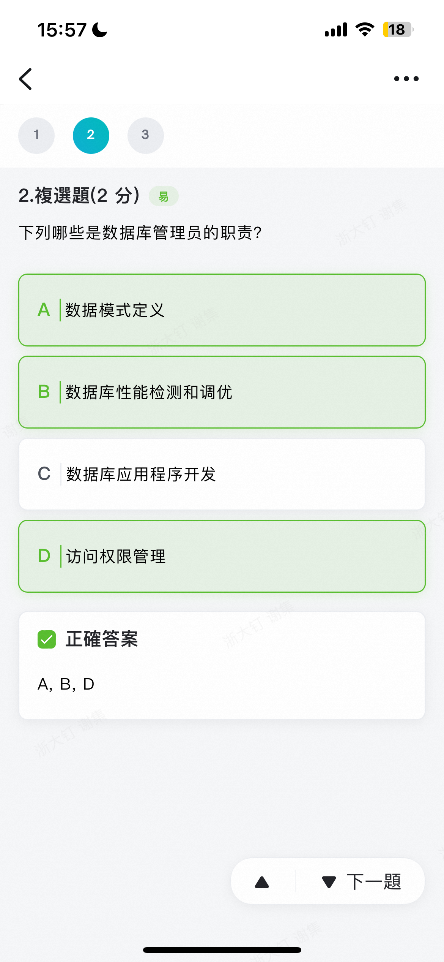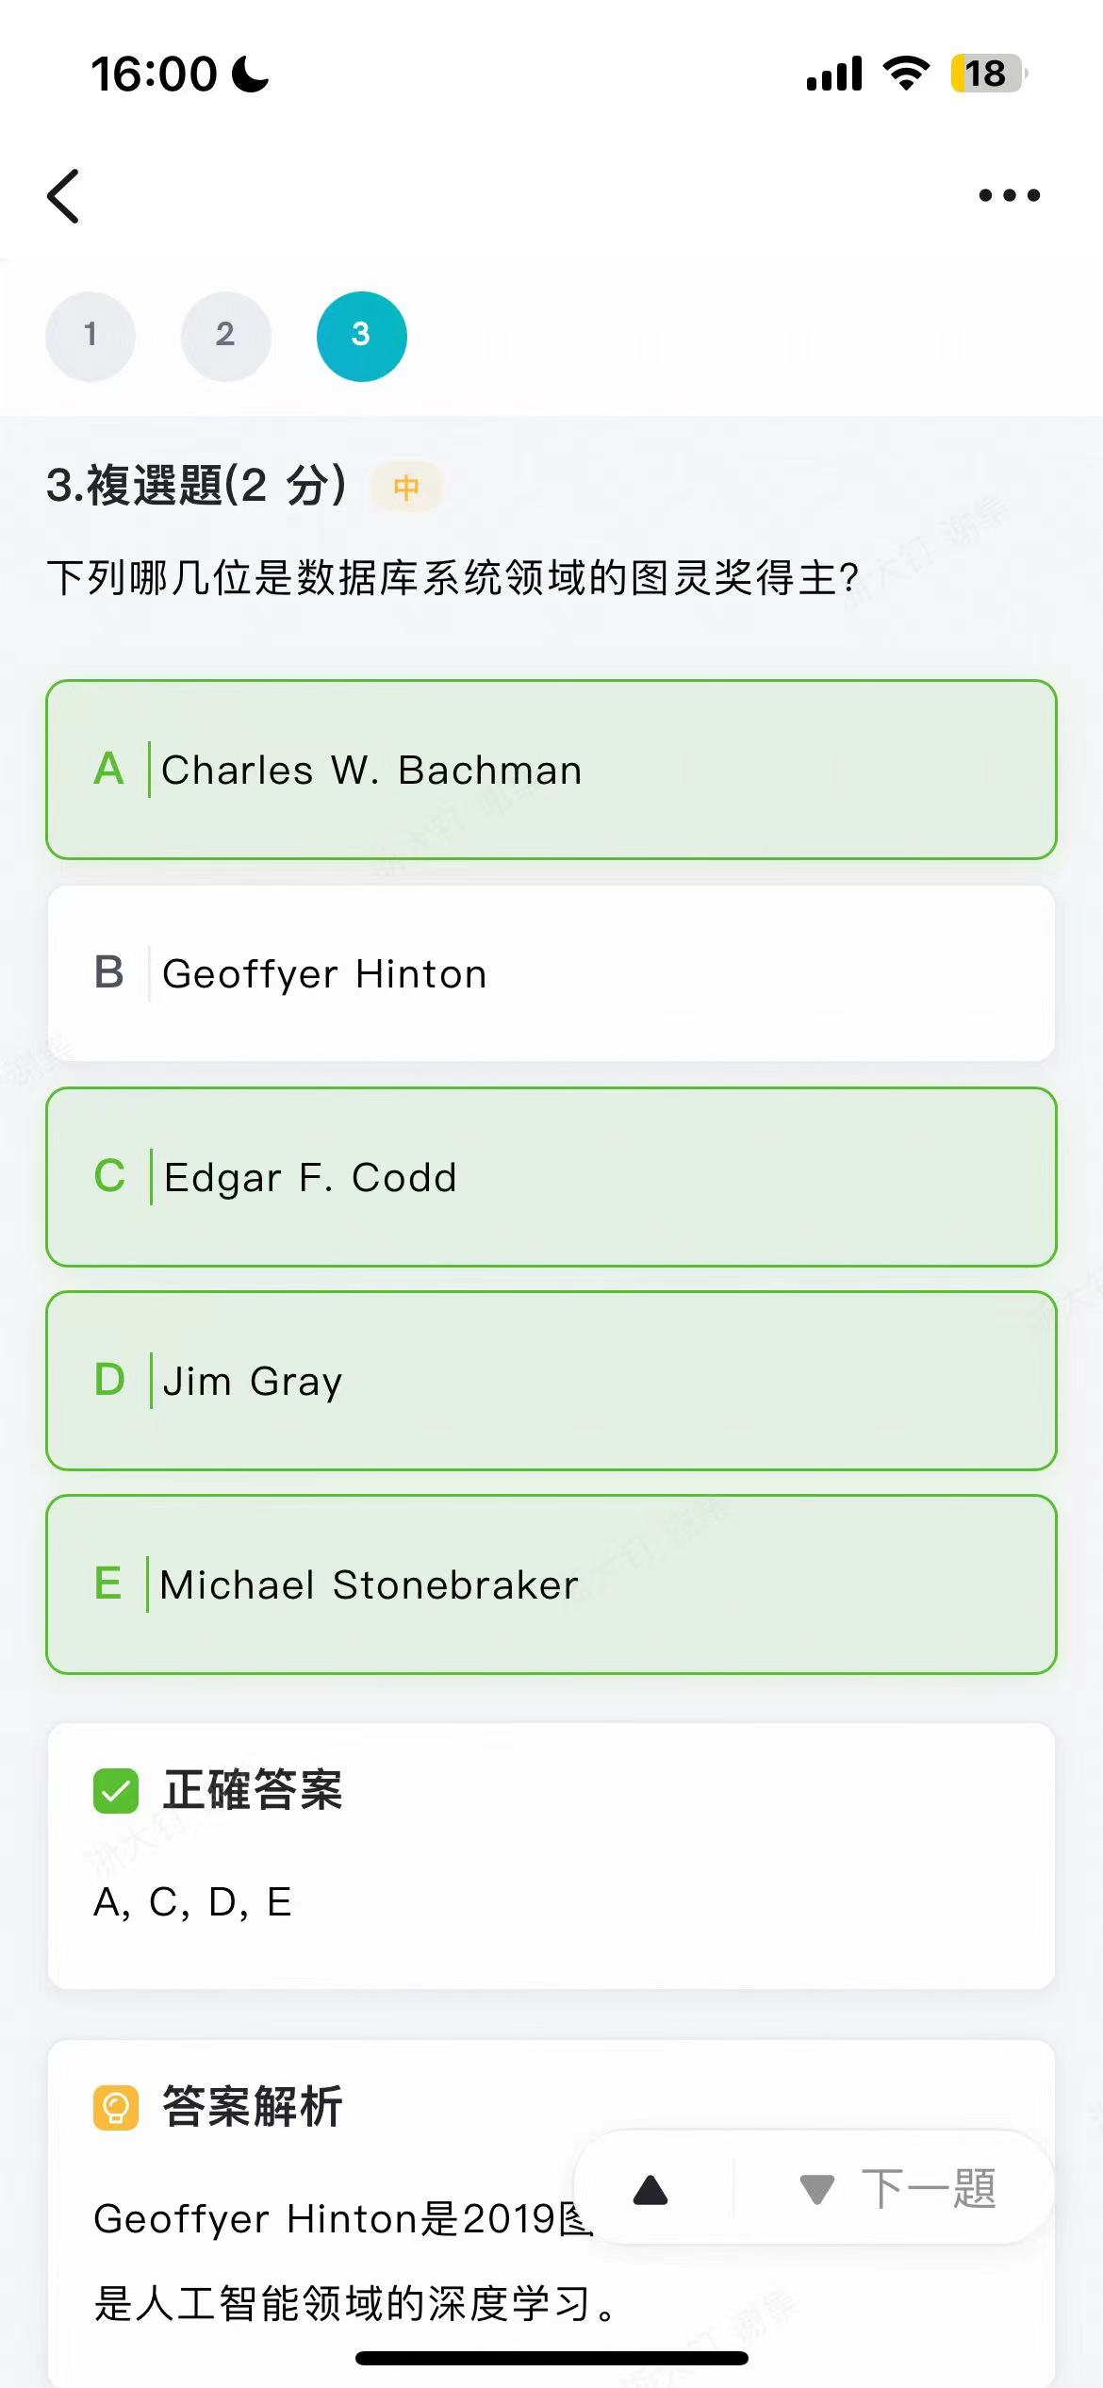

很难评价只能说，第一章的看个乐好了（应该不会考的）。

**Week2：**

1. 下列哪几个操作不是关系代数的基本操作？
2. Set union
3. Set intersection
4. Set difference
5. Cartesian product
6. Division operator

BE。6个基本操作是select、project、union、difference、cartesian product、rename。其他都可以推出来。

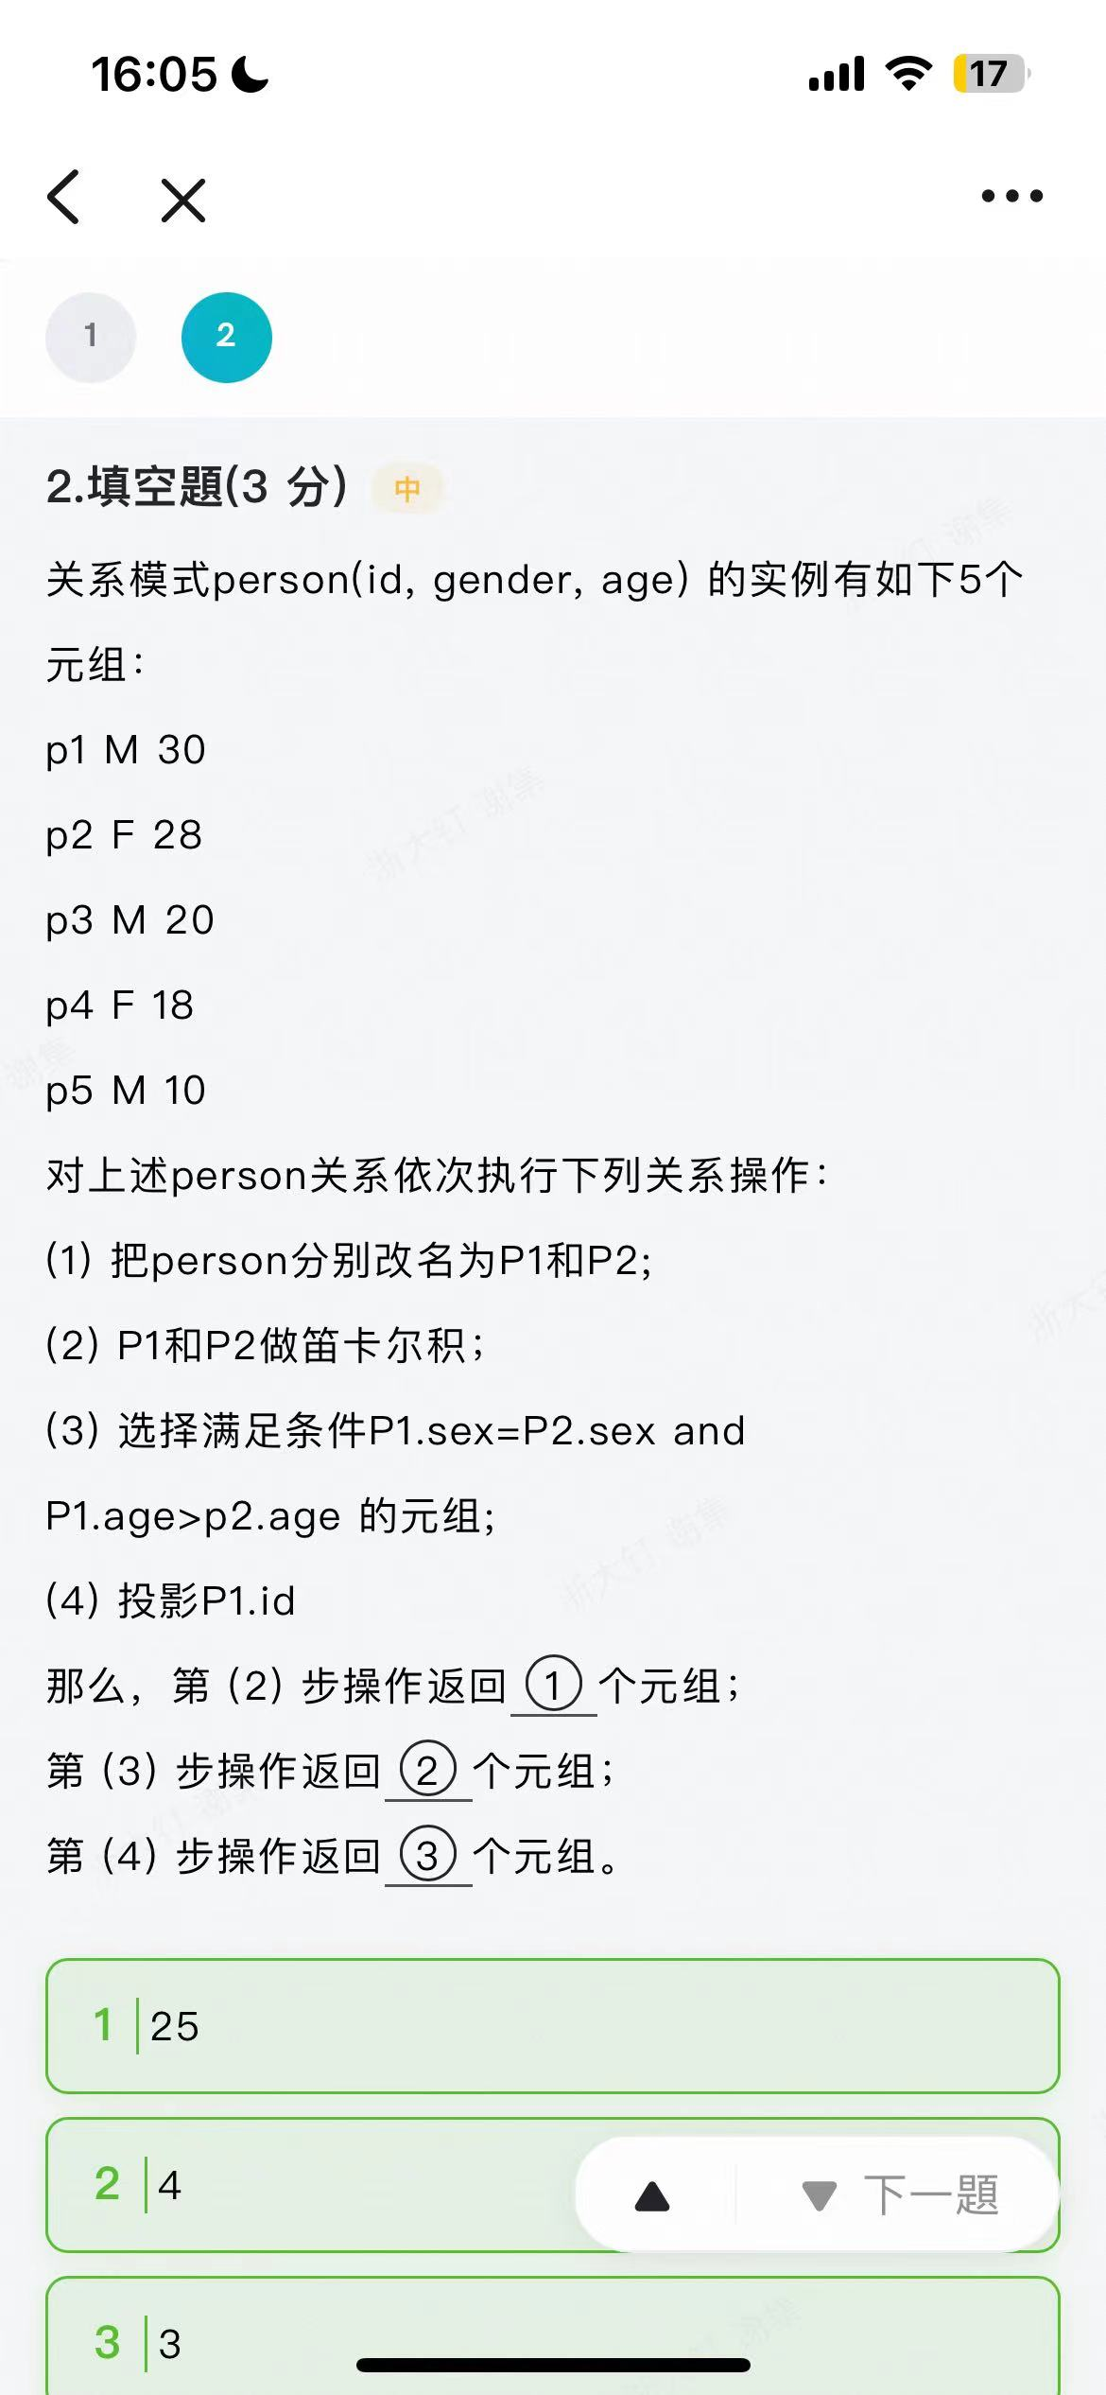

很基础，不解释。

**Week3：**

The table person is defined as following:

create table person( id char(3),

pid char(3),

primary key(id),

foreign key (pid)

references person on delete cascade on update cascade);

An instance of the table <person> is as following

id pid

001

002 001

003 001

004 002

005 004

006 003

007 006

1. The result of the following statement is: __________

select count(*) from person where pid is not NULL group by pid having count(*)>1;

1. After running the following statement:

delete * from person where id='001';

the result of the following statement is:___________

select count(*) from person;

2 0。第一问按照pid分，只有pid=001满足条件，然后里面有2个。其实本来得到的应该是一张表，但是表里只有一个数据。

第二个经典坑题，删了 001，多米诺骨牌一样，全删掉了。

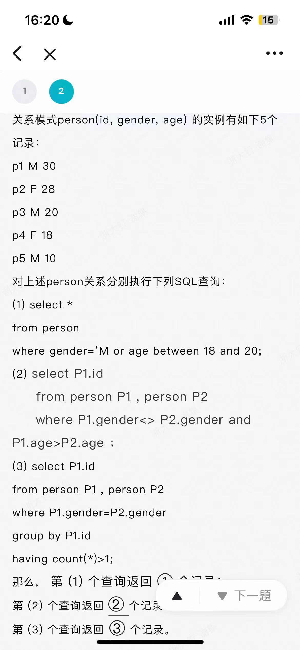

题目改了，第三小问是having count(*)>2.

4 6 3. 不然是 4 6 5.

**Week4:**

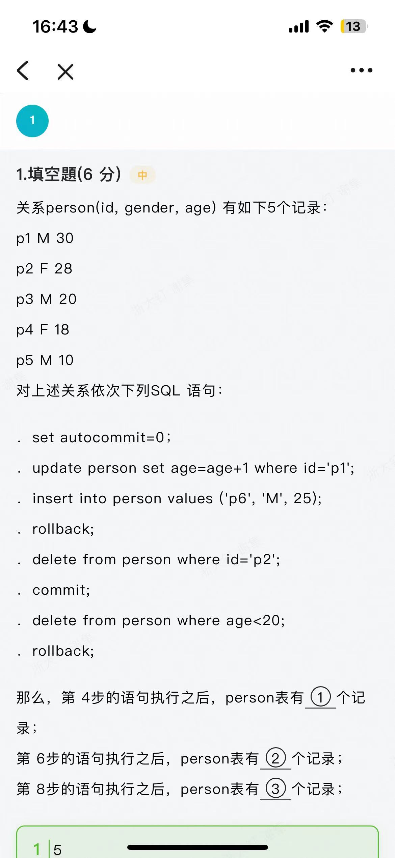

5 4 4.

**Week5:**

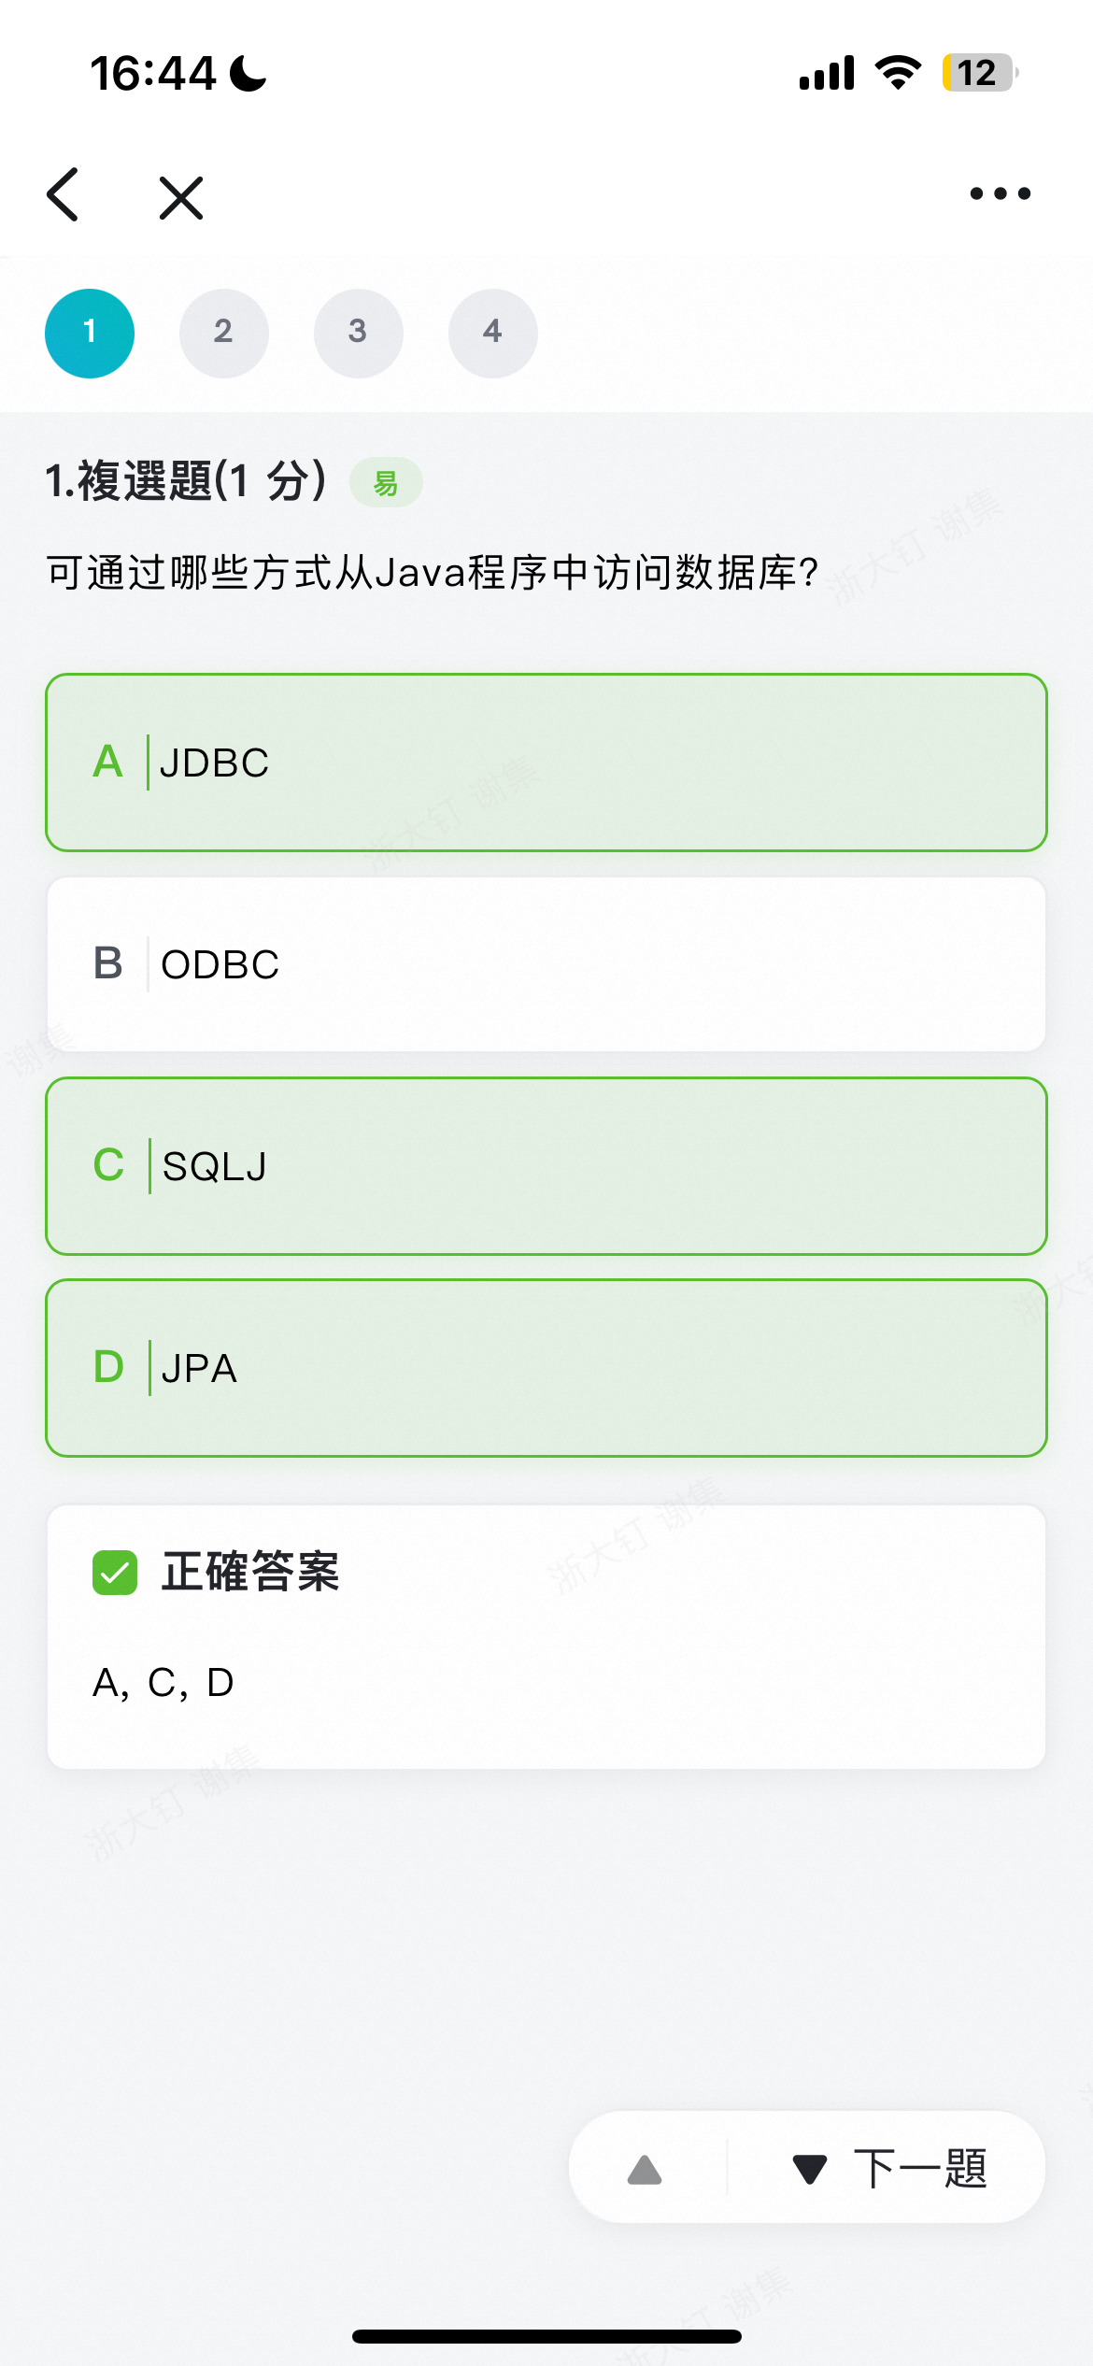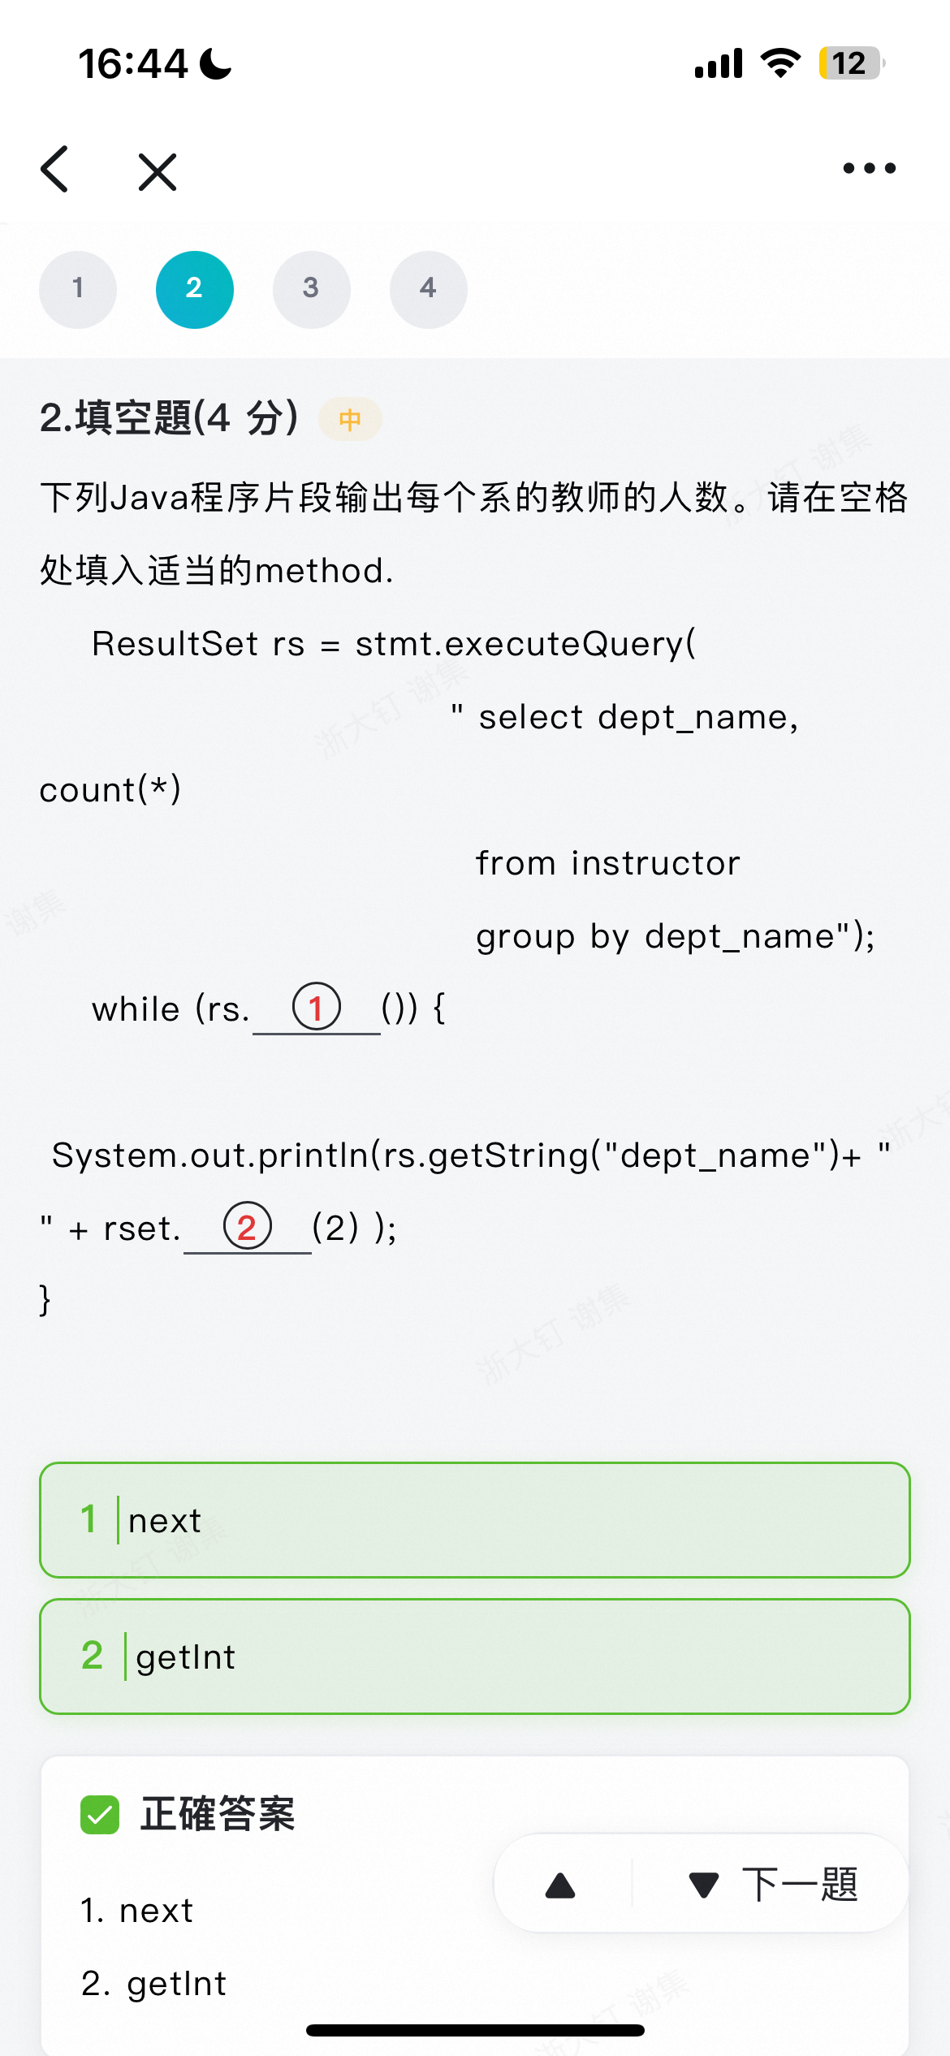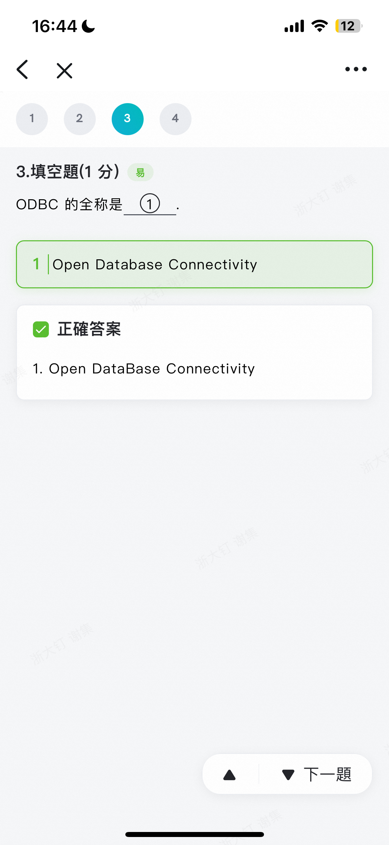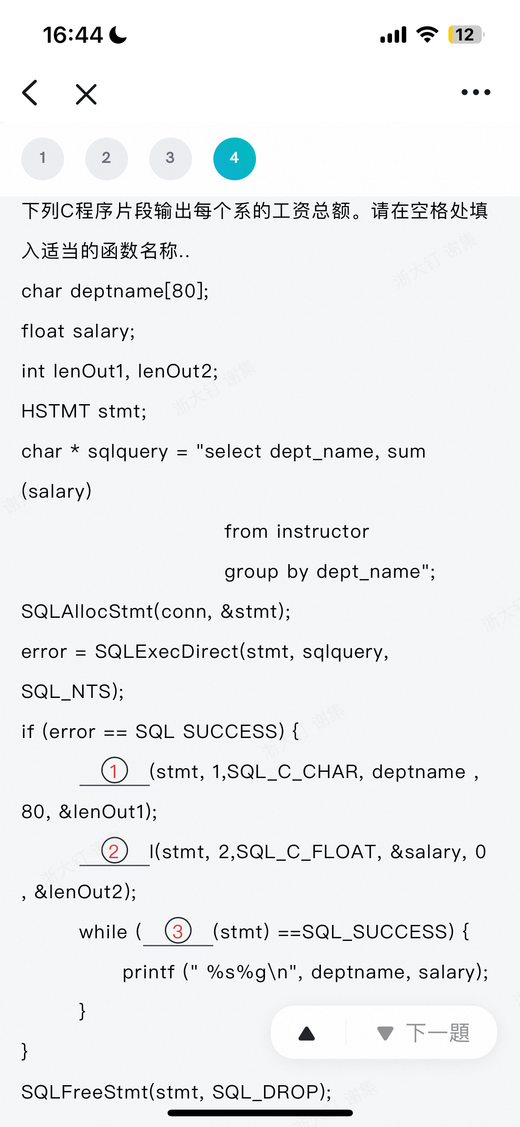

Cheeting sheet，请…

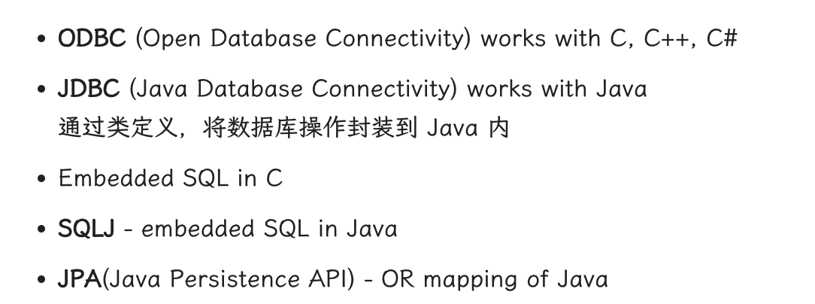

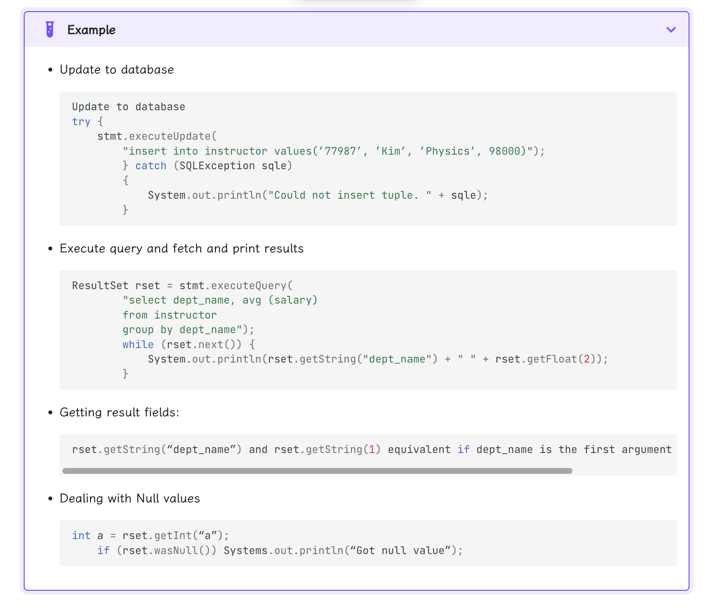

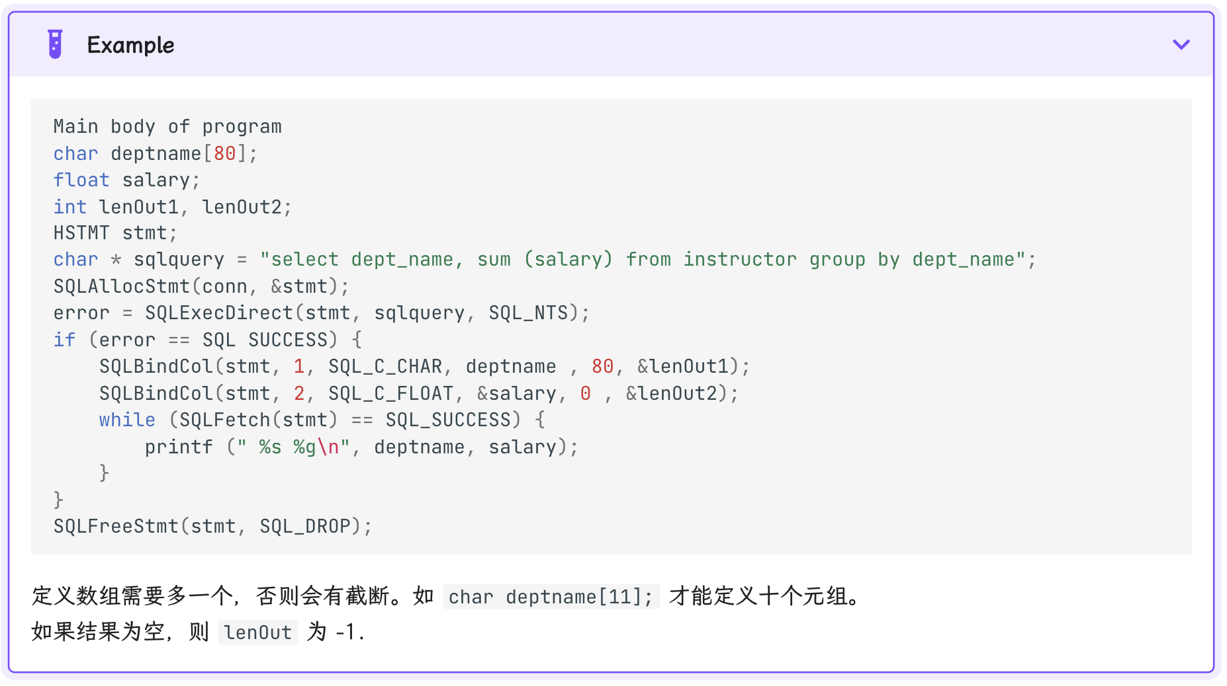

**Week6:**

